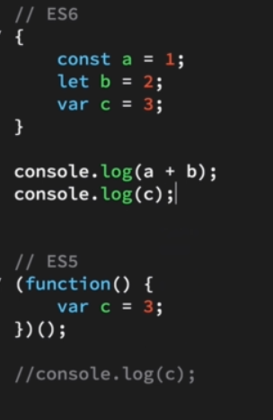

{block} -> iffe for const and let not var